**SCRIPT**

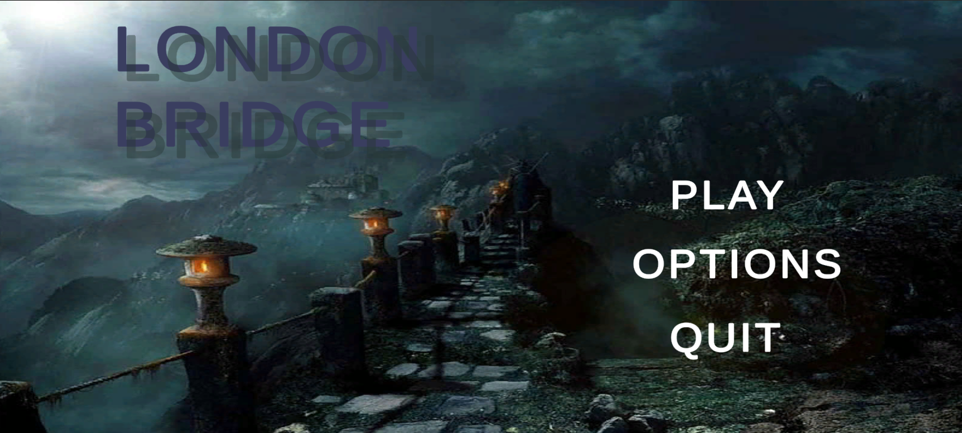

When Quit Button Is Pressed, Game Will Be Closed

When Options Button Is Pressed, Multiple Options Will Be Shown To Change Volume , Sensitivity, etc.

When Play Button Is Pressed, Next Level Will Be Shown

*At the beginning of the game, a player is at the start of the bridge.*

1. *A player can do movements like run or crouch. He will be followed by ghosts, i.e., there will be many horror scenes through which the player has to run.*
2. *There will be various sound effects throughout the game to help the player more effectively immerse in the game environment.*
3. *The game would be more of a walkthrough rather than a game.*
4. *The game takes on London Bridge, on the night on which there was a lot of fog and wind.*

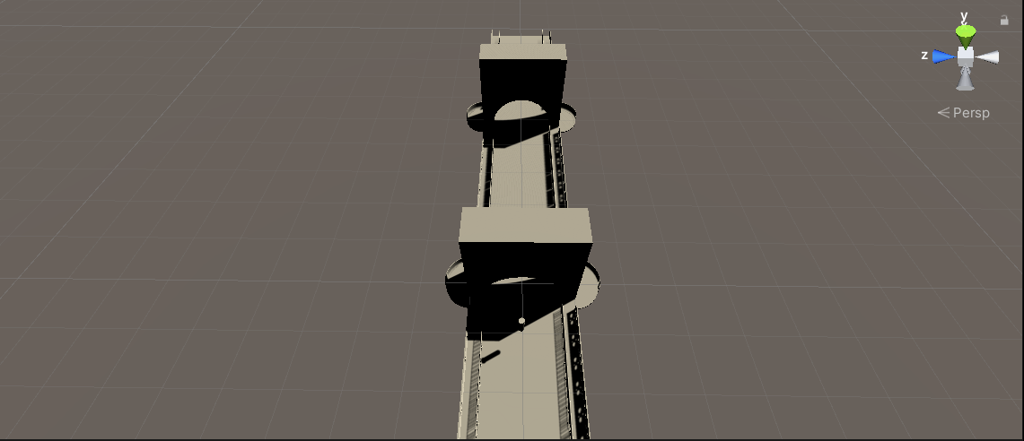

* + In The Beginning, the Player starts to walk
  + At the third step, HAUNTED SOUND EFFECTS are played
  + After another two steps, the voice of running is heard
  + After another two steps, the ghost goes from behind the player
  + After another two steps, a group of children comes from behind the player singing the London bridge song.
  + After going ahead, the player, children disappear but their singing voices remain

* The Movement Player Stops For more than 10 seconds at the same place, he will fall from the bridge
* After another two steps, constant obstacles start to come
* Player has to Jump and Avoid These Obstacles
* Obstacles can be running ghost singing children or vehicles or barricade etc
* There will be a constant ghost haunting the player.